

Small Lettering Guide

Keyboard Lettering
- Fatten thin Fonts (Use 1 pt. Absolute Pull Compensation)
- Turn off short stitches
- Lighten density
- Use only capital letters for very small text
- Use fonts that are digitized for small lettering (micro series)

Misc. Tips
- Use a smaller needle (65/9)
- Use a stable backing, a layer of no-show between cut-away and the garment works well
- Use facing (Solvy) on pique

Digitizing Small Lettering
- Use vector lines (or grid) for letter stroke width and height consistency.

- The clearer the artwork the better the consistency of each letter.

- Lighten density (4.2 – 4.8 pts).

- Underlay / Travel Stitch length (15 -18 pts).

- Turn off short stitches.

- Add a minimum of 1pt. Absolute Pull Compensation to thicken thin lettering.
- The design may look too thick on your screen, this is normal.

- Use capital letters for really small text.

- Enlarge the holes in letters like “R P S B” and “o p a d e b g” so they don’t close up.

- Straight vertical letters tend to push upwards and downwards as they are sewn. Compensate the bottom and top of horizontal types of letters by slightly shortening the top and bottom of letters like W Y I A H K X V N M.

- Round letters tend to pull inward when sewn. They should be digitized slightly larger than the other letters, extending past the baselines. Examples are the letters CGJOQS.

- Underlay:
- Always underlay a complete letter at a time
- Do not use automatic underlay, use Walk Normal elements instead
- Stitch two center runs down the center of the letter
- Stitch length should be around 15 – 18 points

- Tie in stitches (lock stitches):
- Use Style 1 type
- Tie off stitches (lock stitches):
- Use Style 1 type

- For real small letters use two – three manual stitches for the center leg of “A” and center part of the “e” instead of a column.

- Walk between as many letters as possible to keep the machine sewing at speed instead of stopping and starting for a trim after every letter.
- Use a walk stitch and click to create a needle penetration between the letters to bury the stitch (this hides the connecting stitch).
- Inform customer that for best quality it is best to enlarge very smaller letters and move them closer together.

- Help mitered corners look square by allowing the thread to turn more gradually in and out of the corners.
- The letter will look better if the corner points are moved up and out by two points each.
Move up and out 2 pts

- Make sure that column widths are at least 12 points / 1.2 mm

- Letter Height minimums
- .20 inches for non-hat embroidery
- .25 inches for hat embroidery

Other digitizing hints:
- Serif Letters
- .25 inch letter height or larger, a vertical (90 degree from the main leg of the letter) column stitch is clearer.
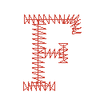

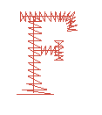
- .24 inch letter height or smaller, a horizontal stitch direction for the serif is best.

- When digitizing an L, the top of the letter may look pointed. If so, flair the edges outward slightly.

- The dot for a letter “i” is much more effective when sewn in a star pattern, rather than a traditional satin stitch rectangle.
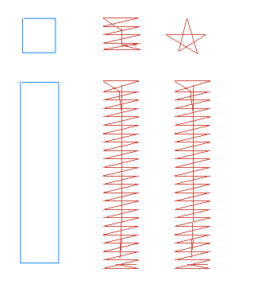

4. Cornering technique 1 Cornering technique 2

