Please follow these steps to convert your graphics to embroidery. There are 3 different options you can use for vector conversion. The design I am using is the coffee cup from the graphics folder included with your Design Shop software on the local drive (C:Designs\Graphics\Coffee Cup.eps).

Option 1 – Convert the entire graphic to stitches
- Open the graphic into DS Software.
- On the right side of the screen will be the project view.
- Left Click on the graphic to select it.
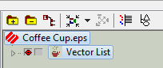

- Click on the “Convert” tool located on the “Property” Bar.

- Your graphic is now converted to stitches.
- Click on the 3D button to see the stitches. You will can also see the stitch count on the Scale Bar.

Option 2 – Convert one element at a time to stitches
- Open the graphic into DS Software.
- On the right side of the screen you will see the project view.
- Select the element in the project view that you want to convert to stitches (you can also click on the element on your display screen).
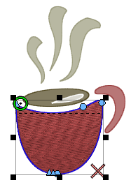
- Click on the “Convert” tool located on the “Property” Bar.

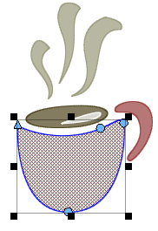

- Your element is now converted to stitches.

Option 3 – Convert with more control of the element’s thread path and stitch direction.
- Open the graphic into DS Software.
- Locate the Project View on the right side of your screen and select the element you want to convert to stitches.
- Locate the Input toolbar (usually located on the left side of the screen) and click on the “Insert Entry / Exit Points” tool.
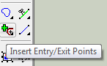

- Left click on the element to input the entry point (a green circle will appear) – this is where your stitches will begin.
- Left click on the element to input the exit point (a red X will appear) - this will be where your lock stitches are placed.
- Left click and drag your mouse across the element – this is your stitch direction.
- Your element is now converted to stitches.

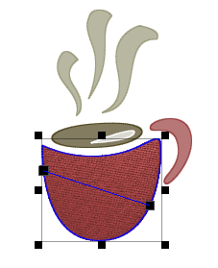

*For more information on graphics or vector conversion please see the Design Shop help system.

