Embroidery Shop Supplies

Whether you are starting and new embroidery business or maintaining an existing business, there are some essential supplies that are necessary to maintain in every shop. Below is a list of suggestions and a general description for supplies of the items you will need to get started or add to your existing business.

Embroidery Supplies
- Needles – Needles can greatly affect the quality of your embroidery. Take the time to research what is the correct type for your specific applications.
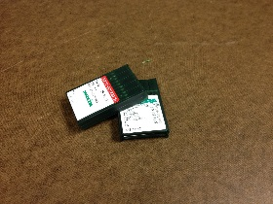

- Thread – Thread is a necessity for any embroidery shop. Your machine manufacturers can usually recommend specific types and brands.
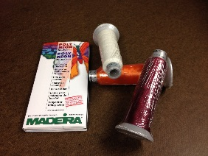

- Bobbins – All commercial embroidery machines use bobbin thread. They usually come in white and black colors, in boxes of 144.
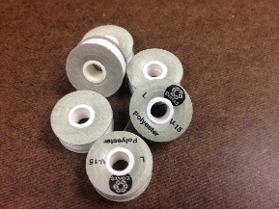
- Backing – Have several different types of backing available for multiple uses. Cut-away, tear-away and specialty backings are available in many different weights and sizes.
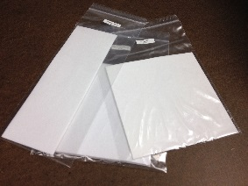

- Scissors – You will need a good pair of scissors to cut backing away from garments. Another necessity is a sharp pair of small scissors to trim threads.
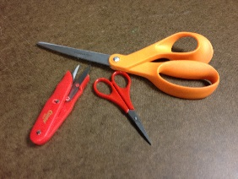
- Hoops/Frames/Cap Frames – Included with your machine are usually hoops and frames. There are many different sizes of hoops for different applications.
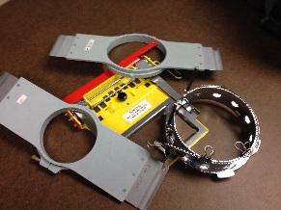
- Hooping Aids / Device – This is a nice tool to help embroiders with consistent placements on garments of all sizes. There are many different types available to choose from.
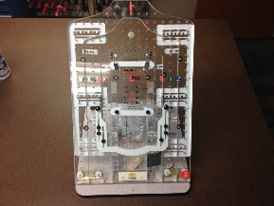
- Stitch remover – These are tools used to remove stitches from garments. A must for every embroidery shop.
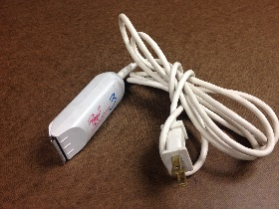
- Frey check – Used for securing frayed ends of material or loose thread.
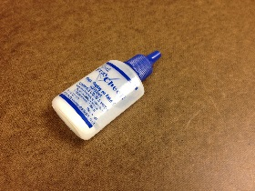

- Fabric markers – These are used to cover up finished areas of embroidery that is not desirable to the eye. They come in a variety of different colors.
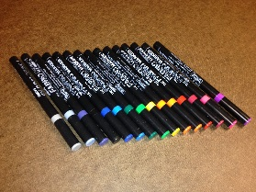

- Spray adhesive – This is used to temporarily attach backing to fabrics to help with hooping. Spray adhesives are also used for appliqué and tackle twill placements.
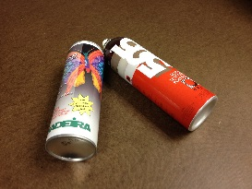
- Topping – Used to hold down the nap on specific fabrics (pique, fleece, terrycloth). It is also a nice tool for a crisper effect of the embroidery stitches on some fabrics. Topping is removed with water or heat.
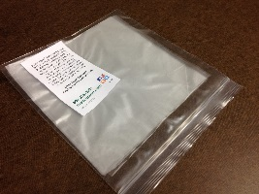
- Oil/Grease – All commercial embroidery equipment requires regular lubrication. Use the type of oil and grease that your equipment manufacturer recommends.
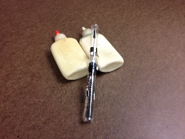
- Canned air – Used to clean the fibers and dust from your machine, especially the hook area and bobbin case. It is also a nice tool for threading embroidery machines, such as Melco.
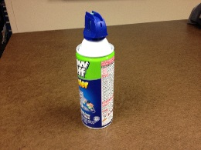

- Machine tools – Machine tools are usually included with your machine and are necessary to enable you to remove parts, such as the needle plate.
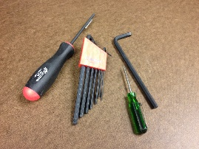
- Sample fabrics and hats – Keep these on hand for test sew-outs of an embroider design that has never been sewn. Try to do a test sew-out on a similar type of fabric that the design will eventually be sewn on.
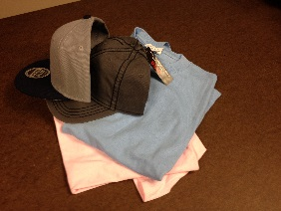
- Pins/marking tools – Some garments may require a pine or mark for exact placements.
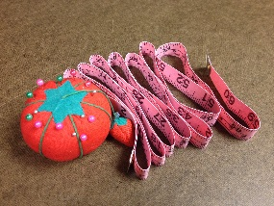
- Placement charts – There are many different placements for garments and hats. Have a placement chart handy for when the placement is in question. You can google “embroidery placement charts to get a variety of placements.

- Tape measurers – This is a nice tool to help with placements of embroidery.
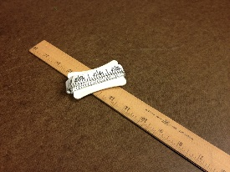
- Water spray bottle – Used for general cleanup and removal of toppings.
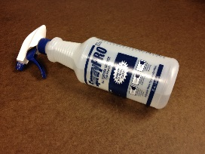

- Steamer or spray starch – Used to remove “hoop” burn from delicate or dark fabrics.
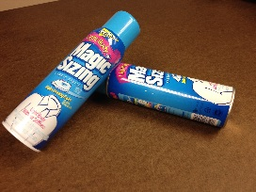
- Static spray – In dry climates static is common and can be harmful to your machinery. Sprays are available to eliminate this from your embroidery work area.

Business Supplies
- Computer / Laptop – A must for any business.
- Printer – A printer can be used to print your designs for a customer approval. Also necessary for printing invoices.
- Dual Monitor – If you haven’t tried a dual monitor, it is the best thing since sliced bread! Very nice for multi-tasking. You can have your embroidery software on one monitor and your email on the other.
- Internet – Also a must for any business.
- Phone – Goes without saying.
- White board – Use this to quickly right notes on needed supplies or anything that pops in your head that you need to do. You will get busy, think of something you need and forget it. If you have a white board you can quickly make a note.
- Q-Tips – These are very nice for machine maintenance…greasing or cleaning behind needles and other parts of your embroidery machine.
- Trash Can – Put one right next to your embroidery machine so you’re not dropping thread or backing on the floor.
- Website – Make this a priority!
- Business cards / Flyer – Take your business cards everywhere you go and hand them out. You never know when someone will need embroidery – your will be very surprised.
- Wholesale supplier catalogs – Get your sales tax license so you can buy garments / hats at wholesale.
- Office supplies – Pens, paper, stapler, file folders, etc.
- Flash Drive – Sometimes you need to transfer or move designs from one computer to another. Flash drives are always a necessity.
- Invoicing / Billing software – If you are going to do your own billing you will need something to create your invoices.
- Power strip – There is always a need to plug in lights, computers, printers, etc.
- Flashlight – This is handy for oiling and greasing parts of your machine that are hard to see.
- Sharpies – Black sharpies are nice for marking boxes. You can also use them to clean up bobbin pull on black thread (if it is showing).
- Copy Paper – Just a reminder you will need paper to print you invoices or designs.

Other
- Heat Gun – A heat gun is a necessity if you will be sewing on 3D foam.
- Boxes / Bags – You may need to ship products or deliver products.
- Tape - Tape Gun, marking tape, masking tape
- Sample bins for fabric – Have sample fabrics to sew your samples.
- Good Lights – Very important!
- Cleaning Supplies – If you have customers coming into your business you always want to make a good impression.
- Iron – Some materials may need to be ironed before or after embroidery.

